**PROJECT TITLE: Decision Tree Classification Using Weka(J48 Algorithm)  
  
 Submitted by:  
 Alina Julie A  
 Student ID:  
 CA/JU1/7990  
 Date:  
 25/06/2025  
  
Objective:** To classify data and predict outcomesusingthe **J48 Decision Tree** algorithm in Weka , a data mining tool.  
  
  
**Tools Used:**

* + **Software**: Weka 3.9 (Waikato Environment for Knowledge Analysis)
  + **Algorithm**: J48 (Java implementation of the C4.5 Decision Tree algorithm)
  + **Operating System**: Windows 10 (or your current OS)

**Dataset Details:** The dataset used in this project is a small credit scoring dataset.

* **Dataset Name**: credit.arff *(Created manually in Weka)*
* **Attributes**:
  + income (high, medium, low)
  + student (yes, no)
  + credit_rating (good, bad)
  + paid_loans (yes, no)

**Class Attribute**: creditworthy (yes, no)  
 • **age**

• **income**

• **debt**

• **paid_loans** (whether the person has previously paid their loans – yes/no)

* **Number of Instances**: 5

This dataset is used to determine whether a person is creditworthy based on their financial history.

**Steps Followed:**

1. **Download and install Weka 3** from the official website or SourceForge.
2. **Launch Weka** and click on the **"Explorer"** tab on the right side.
3. **Create the dataset**:
   * Open **Notepad** or any text editor.
   * Type the ARFF dataset code manually.
   * Save the file with a .arff extension (e.g., credit.arff).
4. In Weka, go to the **"Preprocess"** tab and click **"Open file..."**.
5. Select and open your saved .arff file.
6. Go to the **"Classify"** tab.
7. Choose **Classifier → trees → J48** from the list.
8. Select the option **"Use training set"** for evaluation.
9. Click **"Start"** to build the decision tree model and view the results.

**Decision Tree Output (J48)  
  
 J48 unpruned tree**

**------------------**

**paid_loans = yes: yes**

**paid_loans = no: no**

**Number of Leaves : 2**

**Size of the tree : 3  
  
Output ScreenShots:  
  
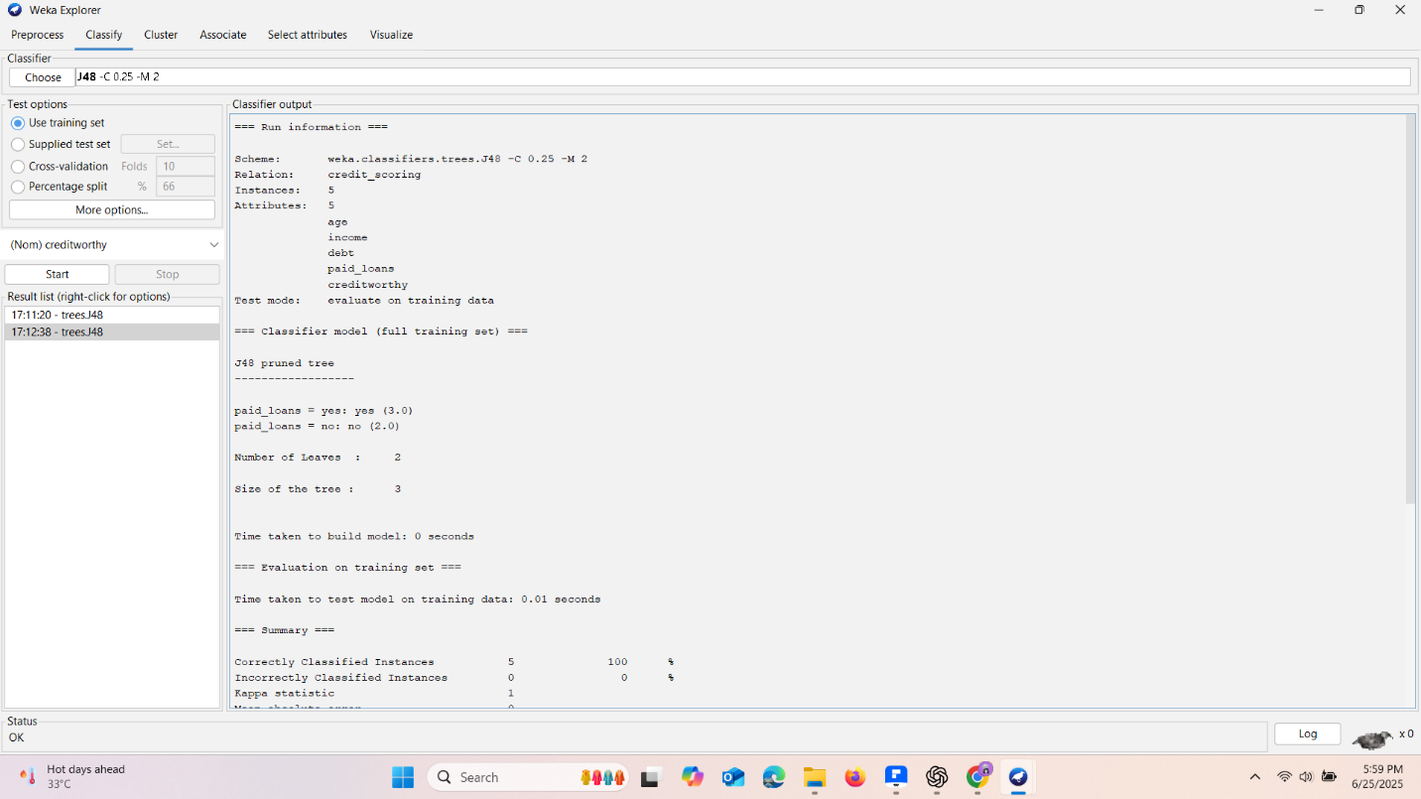  
  
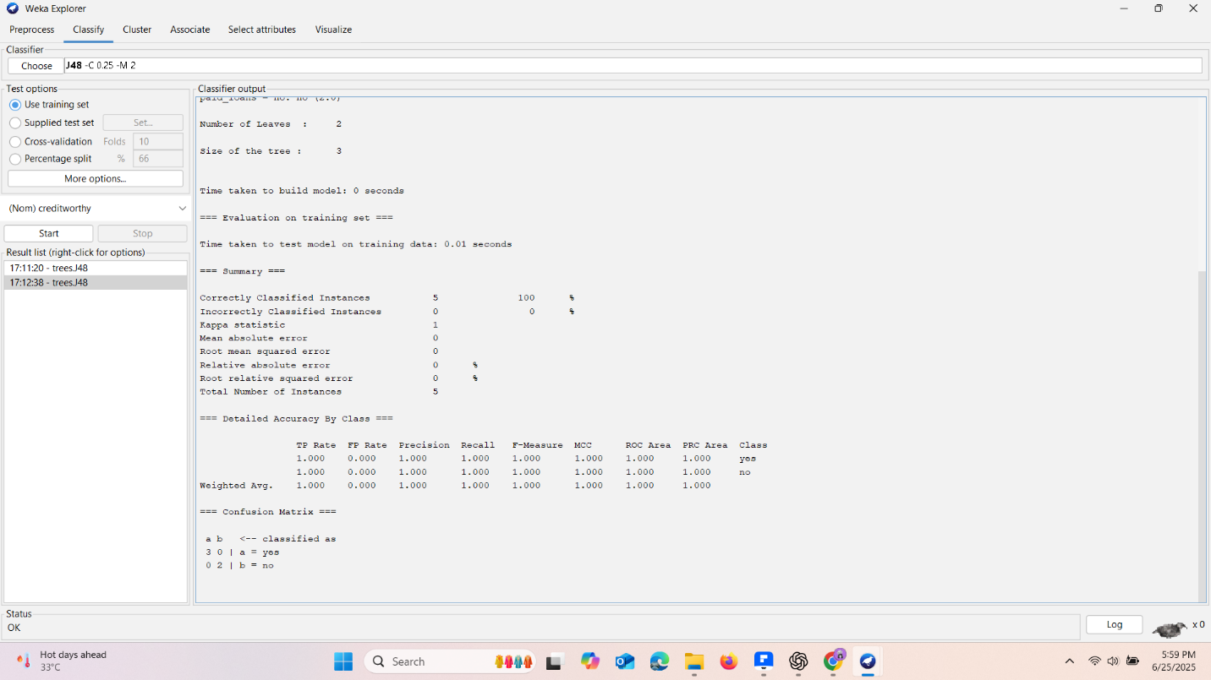  
  
DataSet ScreenShot:  
  
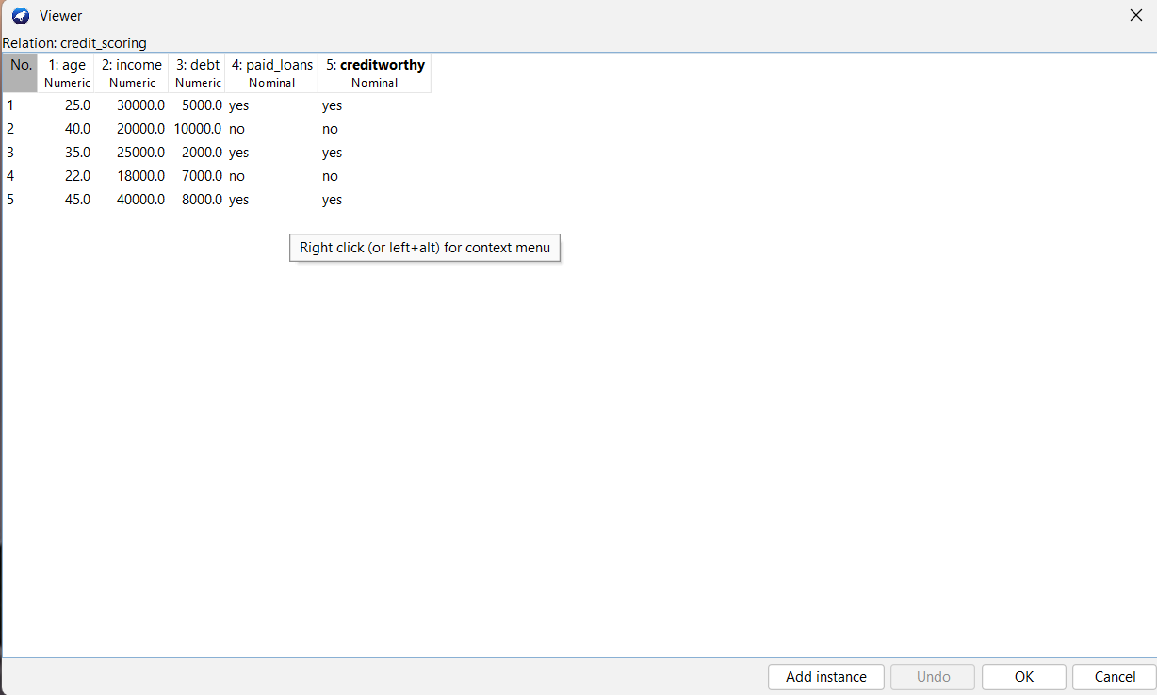  
Evaluation Summary:**• Correctly Classified Instances: 5 (100%)

• Incorrectly Classified Instances: 0 (0%)

• **Confusion Matrix**:

a b <-- classified as

3 0 | a = yes

0 2 | b = no  
  
**Inference:** • The paid_loans attribute alone was sufficient to predict whether a person is **creditworthy**.

• If paid_loans is **yes**, the model predicts **creditworthy = yes**.

• If paid_loans is **no**, the model predicts **creditworthy = no**.

• Achieved **100% accuracy**, indicating that the decision tree perfectly fits the given dataset.

### ****Conclusion****:

This project successfully demonstrates the use of **decision tree classification** using the **J48 algorithm** in Weka. By analyzing a small dataset, we were able to classify instances based on paid_loans and predict creditworthiness with complete accuracy.